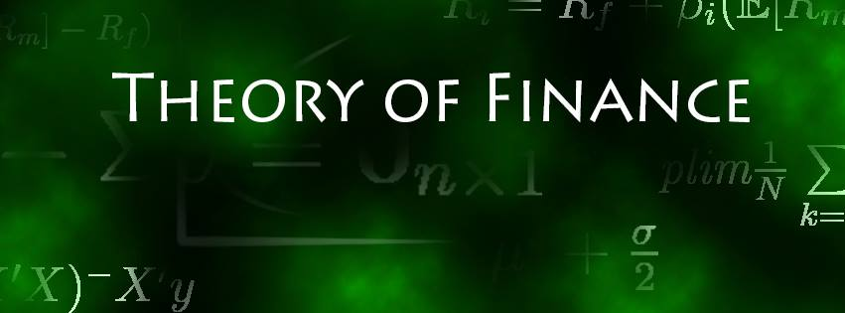

Solution Sheet on Problem Set 1

**Return Calculations, Portfolio Choice and Mean-Variance Frontier**

Deadline: 19.10.2021

**Solved by: Cyril Janak, Niklas Kampe, Jonas Husmann**

|  |  |  |
| --- | --- | --- |
| **Task** |  | **Points Earned** |
| 1. **Return Comparison**   a)  Discrete vs. Log-Returns: mean, st.dev. and annualized  (6 points) | See return variations in code section “Problem 1 – Return Comparison – a)” |  |
| b)  Discrete vs. Log-Returns:  Plot and interpretation  (8 points) | We are using log returns which have a normalizing effect on the data, and therefore the differences in the plot are rather small. Nonetheless, it can be seen that the curvature in the DB plot is slightly more pronounced because there we have the larger maximal difference in discrete and log return. Moreover, there is an upwards curvature in both plots which is because discrete returns are always larger than the corresponding log return. |  |
| c)  Usage of return type  (6 points) | Usually, the discrete return is used for calculating the return of a portfolio (i.e. multiple assets) and when choosing the different weights of assets in a portfolio.  Log returns are used when returns are aggregated across time and when comparing investment horizons for the same asset. |  |
| d)  Investment value  (6 points) | At end the of July 2021 the investment would be worth EUR 814.91. |  |
| 1. **Diversification Effect**   a)  Diversification using two stocks  (6 points) | When looking purely for diversification (regardless of any implies on return) the idea is to reduce the portfolio variance. Given the portfolio variance in this case is defined by $$Var\left(R_{P}\right) = ω_{1}^{2}σ_{11} + ω_{2}^{2} σ_{22} + 2ω_{1} 2ω_{2} σ_{12}$$ the diversification benefit increases with decreasing covariance of the two assets. Therefore, to get the highest diversification benefit an investor should choose stocks Henkel and E_ON as they have the lowest covariance out of the 10 stocks. The worst diversification benefit is achieved by only investing in a single stock (as this would result in the highest covariance). However, given two stocks need to be picked, the worst diversification effect is achieved with investing into RWE and Henkel given they have the highest covariance. |  |
| b)  Diversification and portfolio volatility  (12 points) | Stocks based on return standard deviation from high to low:     |  |  |  |  |  |  |  |  |  |  |  | | --- | --- | --- | --- | --- | --- | --- | --- | --- | --- | --- | | Nr. Of stock | 1 | 2 | 3 | 4 | 5 | 6 | 7 | 8 | 9 | 10 | | Mean St. Dev.: | 0.123 | 0.112 | 0.108 | 0.105 | 0.103 | 0.101 | 0.098 | 0.096 | 0.094 | 0.091 | | PF St. Dev.: | 0.123 | 0.094 | 0.090 | 0.087 | 0.083 | 0.077 | 0.075 | 0.074 | 0.071 | 0.069 | |  |
| c)  Visualization and interpretation of b)  (12 points) | The figure shows that standard deviation of the equally weighted portfolio decreases stronger with increasing number of stocks, compared to the mean standard deviation of its stocks. This means that there is less risk, i.e. volatility, associated with the equally weighted portfolio compared to the stocks. The standard deviation is lower, since the covariance between the stocks cancels out. For clarification we can look at the formula for the variance of the equally weighted portfolio: $$Var\left(R_{p}\right)=\frac{1}{n}({\overline{σ}}_{ii}-{\overline{σ}}_{ij}){+\overline{σ}}_{ij}$$ Where ${\overline{σ}}_{ii}$ is the average covariance of two returns.  Or simply said: Portfolio variance = individual variance – covariance of the stocks  Here we can see that the covariance of the stocks, lowers the variance (and therefore the standard deviation) of the equally weighted portfolio. |  |
| 1. **Mean-Variance Frontier**   a)  Mean-Volatility Plot  (8 points) |  |  |
| b)  Efficient Frontier  (10 points) |  |  |
| c)  Minimum Variance Portfolio  (10 points) | See minimum-variance portfolio in code section “Problem 3 – Mean-Variance Frontier and Portfolio Choice – c)” |  |
| d)  Tangency Portfolio  (10 points) | See tangency portfolio in code section “Problem 3 – Mean-Variance Frontier and Portfolio Choice – d)” |  |
| e)  Portfolio Choice  (6 points) | Optimal allocation for portfolio in ETF and risk-free asset:  Weight in ETF: 36.84%  Weight in risk-free asset: 63.16% |  |